What to Expect
9th Grade Lit Milestone Study Sheet

Day 1: May 1, 2017 [up to 90 minutes for this portion]
- You will read two passages (probably non-fiction articles).
- You will answer 3 multiple choice type questions about the passages.
- You will answer 1 short answer question about the passages.
- THEN---YOU WILL WRITE YOUR BIG ESSAY! Extended writing-response item—write an argumentative essay or expository/explanatory essay based on information read in 2 passages. The extended writing response task is scored on a 7-point scale: 4 points for idea development, organization, and coherence, and 3 points for language usage and conventions.

Day 2: May 2, 2017 (2 Sections)

SECTION 1: [up to 75 minutes for this portion]

- You will answer Multiple Choice questions. Selected-response items – multiple-choice questions over reading and writing based topics followed by four or more answer choices. 1pt

- { Technology-Enhanced Questions} Some MC questions will have a follow up question that requires you to choose 1 or 2 answers that support/prove (evidence) your answer to the previous question.

- You will answer Short Answer questions. Constructed-response items— question, and you write sentence or several sentences as answer. 2pts.
SECTION 2: [up to 75 minutes for this portion]
- YOU WILL WRITE A NARRATIVE/STORY! Extended constructed-response item— You will be asked to write a narrative based on a prompt or passage you are given. You should include sensory details, dialogue, and specific interesting details. 4pts.
{60 total items}

DEPTH OF KNOWLEDGE (DOK) LEVELS
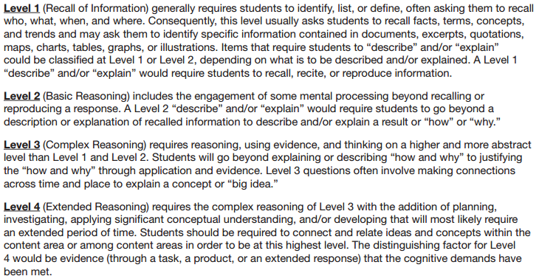

Day 1:
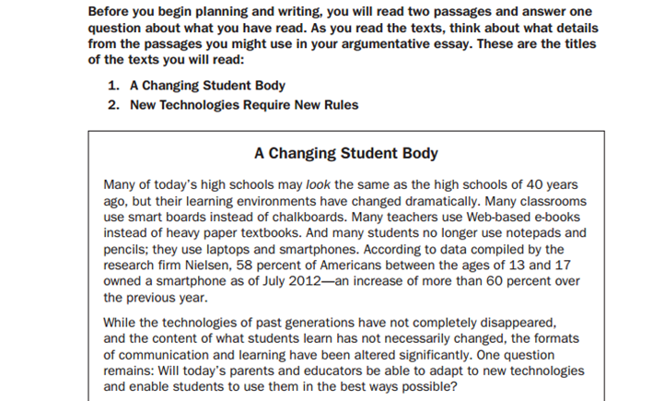
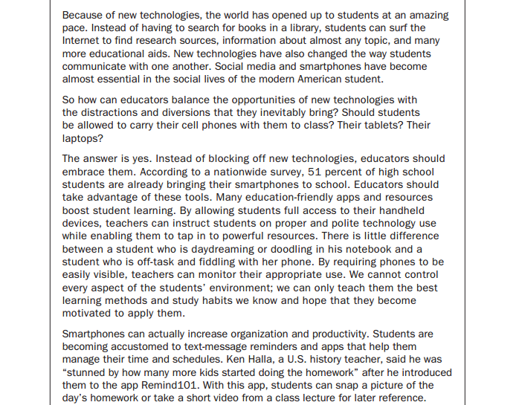
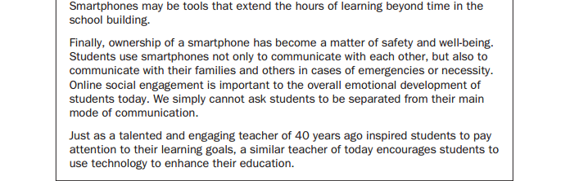
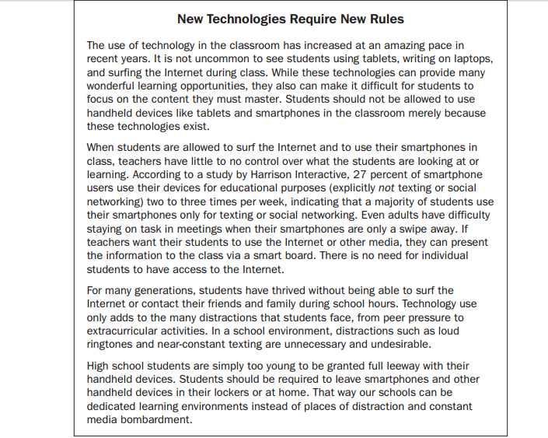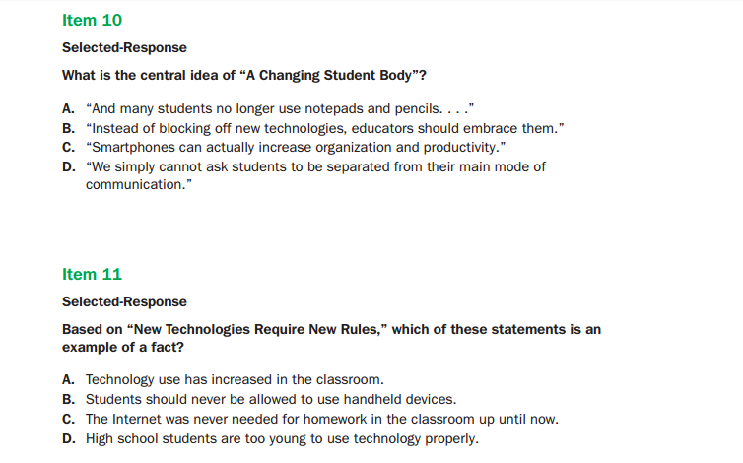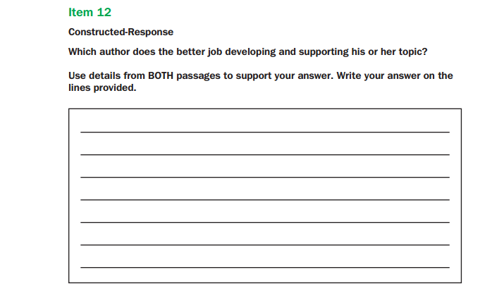
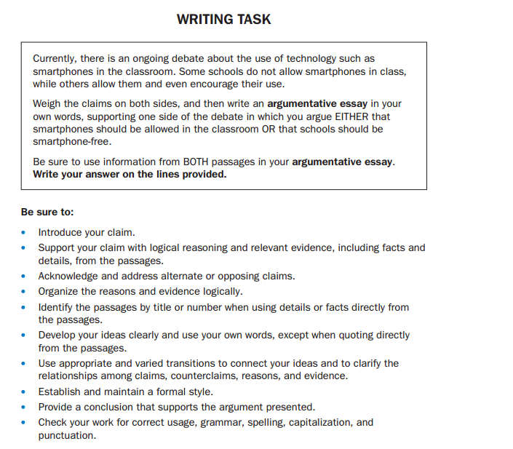
____________________________________________________________________________________________________________________________________________________________________________________________________________________________________________________________________________________________________________________________________________________________________________________________________________________________________________________________________________________________________________________________________________________________________________________________________________________________________________________________________________________________________________________________________________________________________________________________________________________________________________________________________________________________________________________________________________________________________________

Day 2:

FICTION:
- Setting: [When and Where of a story]

- Plot: [5 stages of Plot Diagram: Exposition, Rising Action, Climax, Falling Action, Resolution]

- Character development (characterization): An author may reveal a character through the character’s thoughts, words, appearance, and actions, or through what other characters say or think. An author may also tell us directly what the character is like.
- Direct characterization occurs when the reader is told what a character is like; narrator describes character.
- Indirect characterization occurs when a reader must infer what a character is like; the text provides clues.

- Conflict: [External: (Man vs. Man, Man vs. Society, Man vs. Nature)] & [Internal: (Man vs. Self)]

- Point of view: [1st, 2nd, 3rd (omniscient & limited)]

- Linear/Non-Linear Structure: [With foreshadowing, the author gives hints of what is to come in the future. With flashback, the storyline shifts to the past to give readers important information to help them understand the story better. Other structures include Compare/Contrast]

- Tone & Mood:
- [Tone and mood are often confused with each other. One way to remember the difference is to imagine a passage being read aloud; think of tone as the way the author’s voice sounds and mood as how the passage makes you feel. Tone and mood are usually connected and similar.]
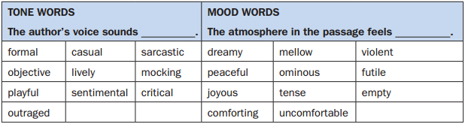

- Theme: [Message/Moral/Lesson of a passage]
  - Topic: Charles tells a lie to avoid trouble with his father, but his lie creates unexpected trouble with his brother.
  - Theme: The lies we tell to cover up an action or situation can often be more damaging than the action or situation itself.

- Imagery: [Sensory details and description language]

- Symbolism: [Object stands for something else]

- Author’s purpose: [Entertain, Persuade, Inform]

- Irony: [Situational, Verbal, Dramatic]

- Figurative Language [simile, metaphor, personification, allusion, hyperbole]:

- Connotation vs. Denotation:

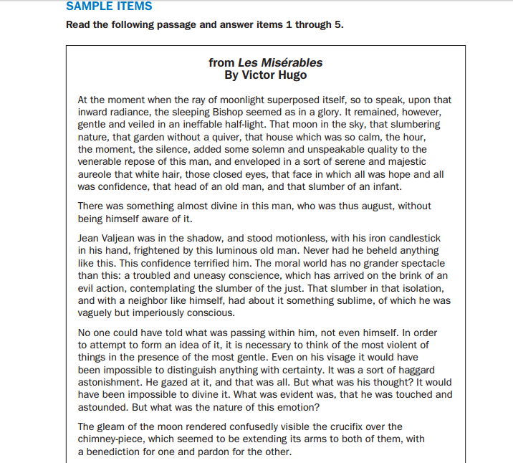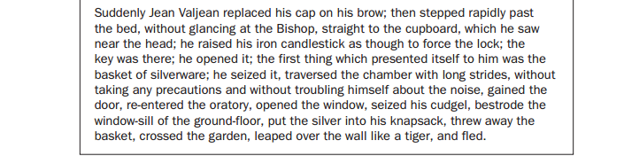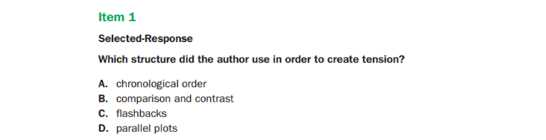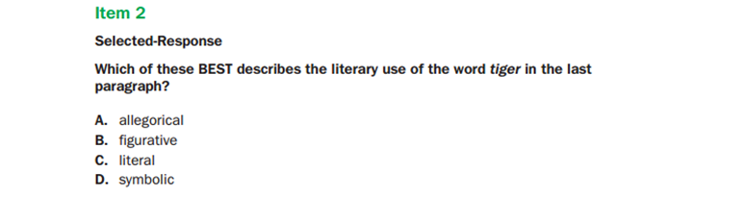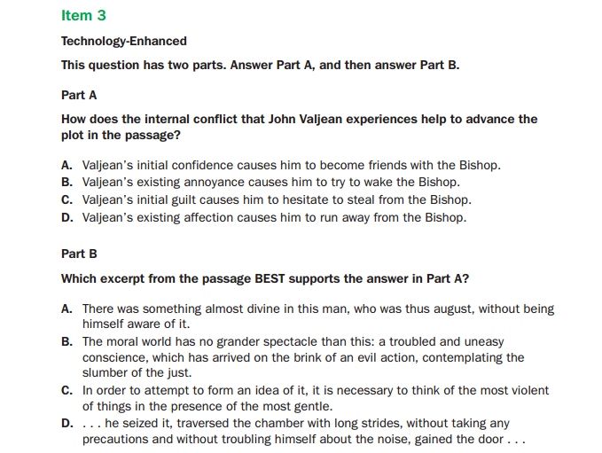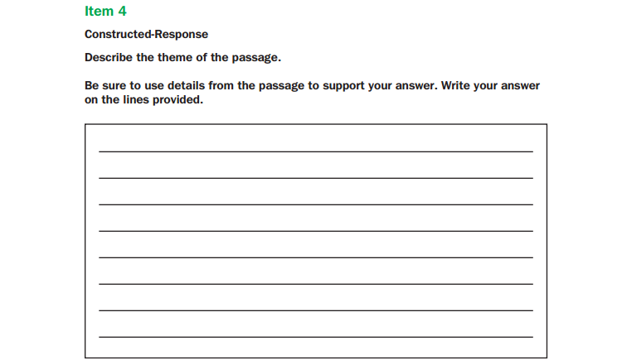
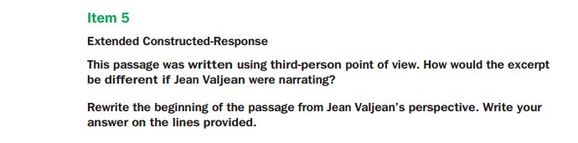
____________________________________________________________________________________________________________________________________________________________________________________________________________________________________________________________________________________________________________________________________________________________________________________________________________________

NONFICTION:
- Central idea: [Main Idea]
- Author’s purpose: [Entertain, Persuade, Instruct, Inform]
- Supporting evidence:

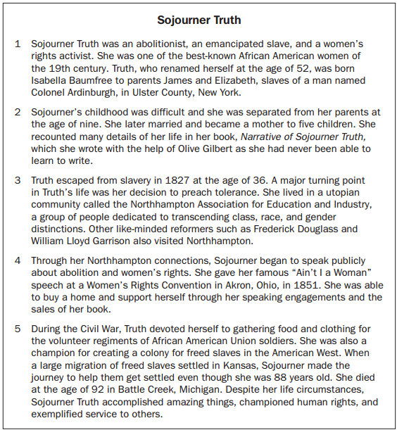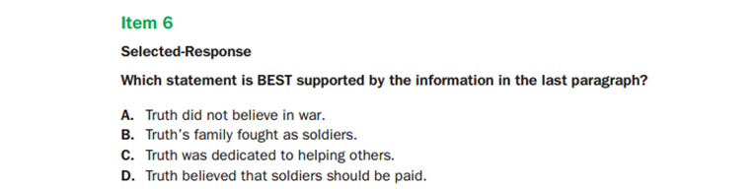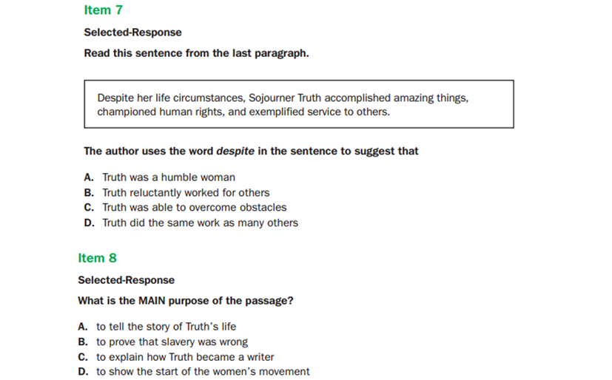

Grammar items on the EOC assessment test these points:
• ensuring subject-verb and pronoun-antecedent agreement
• recognizing and correcting inappropriate fragments and run-ons
• using correctly frequently confused words (e.g., accept/except; there/their)
• recognizing and correcting inappropriate shifts in verb tense placing phrases and clauses within a sentence and correcting misplaced and dangling modifiers
• using parallel structure
• using phrases and clauses to convey meaning and add variety and interest to writing or presentations

Clauses:
• Independent clause: A group of words that expresses a complete thought and can
stand alone as a sentence.
• Dependent clause: A group of words that does not express a complete thought and
cannot stand alone as a sentence.

Semicolon: A punctuation mark that you may not have used in earlier grades is introduced in Grade 9; this mark is the semicolon [;]. This little symbol may seem intimidating, but once you know how to use it you may find that it comes in handy. Looking at the symbol itself, you can see that it looks like a period centered over a comma. One way to think of the semicolon is as a combination of these two other punctuation marks. You can use it when you need something stronger than a comma but not as strong as a period. So how does it work? When you have two related independent clauses (groups of words that can stand alone as a sentence), you need to separate those clauses in some way. One way is to use a semicolon.
